|  |  |
| --- | --- |
| Logo of the European Commission, 12 yellow stars on a blue background arranged in a circle and framed by two light grey graphic elements representing the Berlaymont building, which is the headquarter of the European Commission. | EUROPEAN COMMISSION  DIRECTORATE-GENERAL  TAXATION AND CUSTOMS UNION  Digital delivery of Customs and Taxation Policies  **Processes & Data, Customer Relationship and Planning** |

Guidelines for the Printout of the  
Transit Accompanying Document (TAD) and   
the Transit List of Items (TLoI) for NCTS-P5

Document TAXUD B1 18.09.2024-v.1.4  
  
The document is accompanied by the XLS files containing the templates and the table with the data set

# Introduction

This document is an updated version of the printing guidelines issued by TAXUD in 2008 (Document TAXUD 2008-1671). The information contained are recommendations to complement or enhance the applicable Explanatory Notes of Annex B-02 and B-03 to the UCC Delegated Regulation (2015/2446) and to the Annexes A4a, A6a to Appendix IIIa of the Convention on a Common Transit Procedure (87/415/EEC).

This document must be read together with the embedded XLS files and it only applies to the printing of the NCTS-P5 declaration structure.

# Layout

Whilst the layout of the **TAD** is rigid, i.e. **each** **box** presents a **pre-defined area** (not expandable); the **boxes** of the **TLoI** have to be considered as **vertically expandable**, in order to allow the printing of all the information stored in the system. When this case occurs, **each line** following the one containing one or more boxes which have been expanded, will therefore be **accordingly shifted** down.

In case of multiple occurrences of data elements which don't all fit in one box, only the first and the last instances are printed, separated by “(…)” (e.g. in box Transport equipment [19 07]: 1/CONT123/1/1-3;(…);24/CONT456/1/1). This approach can also be applied in the TLoI.

When several occurrences are printed in one box of the TAD, they shall be separated by semi-colon (;) and a single space after it. The text printed in a box should always end by a full stop “.” to indicate that the provided information is complete. The TAD form includes all information from the “declaration” and “master consignment” levels. The TLoI form includes most of the information from the “house consignment” and the “house consignment item” levels.

Please note that the header of the TLoI must be printed on every new page (e.g. in case of declaration with several goods items).

# Box label & content

Each box includes a label that includes the name of the data group (or data element) and the identifier (data element number) defined in the legislation (e.g. Consignee [13 03]).

All information available in the various data elements of a Data Group shall be printed.

In case only one occurrence is provided in a certain box, the data element “Sequence number” of that Data Group / Data Element can be skipped. Instead, in case multiple occurrences are provided in the same box, it is important to print the “Sequence number” of each occurrence.

Please refer to the XLS Printing Guidelines document, which provides further information on the data that each box must contain.

# Printing of the “bar code”

The readable **bar code** must be printed on the right of “MRN” using the standard 'code 128', character set 'B', complemented by the alpha-numeric digits as indicated below. The font to be used for the alpha-numeric digits is bold Arial, size 7.



**23CH9876AB889012J4**

# Size and forms

The forms shall be printed on a paper sheet measuring 210 × 297 mm (A4) with a maximum tolerance as to length of 5 mm less and 8 mm more.

The models of the forms published in the legal provisions are surrounded by an outside frame that represents the edges of a plain A4 sheet of paper, reduced by a certain ratio, identical in height and in width, to allow its publication in the OJEU. The models of the forms themselves are also reduced by the same ratio in all their components.

The forms shall be printed with black ink (content and layout) on white plain A4 paper sheets.

Please note that the embedded XLS file in section 9 of this document contains the layouts to be used, which are fully aligned to the published layouts of the legal provisions (UCC and CTC).

# Printing of Data Groups Transport equipment [19 07] and Seal [19 10]

To make the correct link between the Data Groups Transport equipment [19 07] and Seal [19 10] the following rules shall be observed:

* **The sequence number printed in box Seal [19 10] refers to the sequence number of the 'Transport equipment' instances.**

**For example: 1**/ID of Seal1, ID of Seal2 on the same equip; **2**/ID of Seal1 on Equipm 2.

* **1**/AB123456, AB123457; **2**/AB123458
* The declaration goods item number provided under the 'Goods Reference' data group is printed in box 'Transport equipment' (e.g. 1/BICU1234565/1/**1-3**; 2/ADCU1234565/1/**4-10**).
* When the goods reference information is not provided in the system, because all the items are in the same container, the declarations goods item number(s) are not printed in box 'Transport equipment'.
* For the transport equipment without seals attached, nothing is printed in box Seal [19 10].
* When more seals are used and each of them is identified with a serial number, only the first and the last numbers of the seals sequence should be printed, separated by a dash line “-“ (e.g. Seal1-Seal10). It is important to note that in this case the seals used must be in sequence, without interruption of numbering. In case more seals are used in the same occurrence and the serial numbers are not in sequence, each seal is separated by a comma “,”.

Visual example:

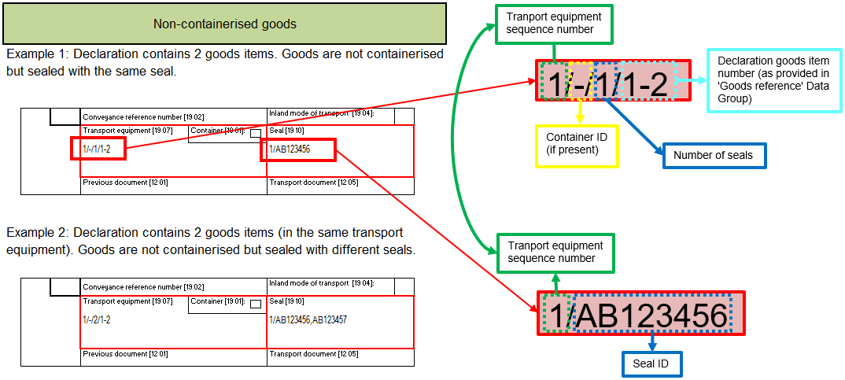

# Printing of Box “Customs Office of Transit [17 04]” and “Customs Office of Exit for Transit [17 06]

For each of both boxes, a maximum of 9 codes will be provided, separated by semi-colon (;) and sorted according to the planned itinerary.

Example: 1/CH123456; 2/IT987654; 3/RS246801; 4/BG999111; 5/TR000123

The fonts mentioned in section 7 below allow the printing of up to 9 “Customs Office of Transit” and “Customs office of Exit for Transit” (sequence number + reference number).

# Printing of box “Guarantee [99 02 - 99 03 - 99 04]”

When Individual guarantee vouchers are used in sequence, i.e. without interruption of numbering, then only the first and the last serial numbers of the vouchers should be printed, separated by “(…)”.

# Fonts to be used

## TAD

One of the following fonts (available in MS Windows environment) must be used to print the content of the declaration:

|  |  |  |
| --- | --- | --- |
| **Font** | **Size** | **Style** |
| Arial Narrow | 7 | Normal |
| Haettenschweiler | 7 | Normal |
| Helvetica | 7 | Normal |

The layout itself must be printed according to the format provided in the forms in the Excel file (the general font size is 5). The following table provides information on specific items:

|  |  |  |
| --- | --- | --- |
| **Item** | **Size** | **Style** |
| Text EUROPEAN UNION[1] (only for EU MS) | 10 | Capital letters + Bold |
| Text TRANSIT ACCOMPANYING DOCUMENT | 7 | Capital letters + Bold |
| Box lines of field TRANSIT ACCOMPANYING DOCUMENTS | - | Thick border |
| Text DECLARATION TYPE | 5 | Capital letters + Bold |
| Box lines of field DECLARATION TYPE | - | Thick border |
| Text MRN | 5 | Capital letters + Bold |
| Box lines of field MRN | - | Thick border |
| Box lines of field Security | - | Thick border |
| Text BCP | 5 | Capital letters + Bold |
| Text Return copy has to be sent to the office: | 5 | Bold |
| Text INCIDENTS DURING TRANSPORT (BCP) | 5 | Capital letters + Bold |
| Text CUSTOMS OFFICE OF INCIDENT REGISTRATION | 5 | Capital letters |
| Lines above and below, delimiting the section for Incidents during transport (BCP) | - | Thick border |
| Text CERTIFICATION BY COMPETENT AUTHORITIES | 5 | Capital letters |
| Line above the fields for the controls by offices of Departure and Destination | - | Thick border |
| Text CUSTOMS OFFICE OF TRANSIT [17 04] | 5 | Capital letters |
| Text CUSTOMS OFFICE OF EXIT FOR TRANSIT [17 06] | 5 | Capital letters |
| Text CUSTOMS OFFICE OF DEPARTURE [17 03] | 5 | Capital letters |
| Text CUSTOMS OFFICE OF DESTINATION [17 05] | 5 | Capital letters |
| Text CONTROL BY CUSTOMS OFFICE OF DEPARTURE | 5 | Capital letters |
| Text CONTROL BY CUSTOMS OFFICE OF DESTINATION | 5 | Capital letters |

## TLoI

The TAD shall be supplemented by a list of items even when a consignment consists of only one item.

The boxes of the TLoI are vertically expandable.

Even if in this case nothing prevents the use of other fonts, only the fonts mentioned in the previous point should be used to print the content of the declaration.

The following table provides information on specific items of the layout:

|  |  |  |
| --- | --- | --- |
| **Item** | **Size** | **Style** |
| Text TRANSIT LIST OF ITEMS | 10 | Capital letters + Bold |
| Text MRN | 5 | Capital letters + Bold |
| Outside box of each goods item | - | Thick border |
| Box lines of field Decl.goods it. Nr. [11 11] | - | Thick border |
| Box lines of field Goods it. Nr. [11 03] | - | Thick border |

## Mentioned fonts not available

If the **above**-mentioned **fonts** are **not available**, other fonts should be chosen, which allow the printing of the integral information of the IE015 or IE029 for all the boxes of the TAD and TLoI. The chosen fonts for the content should also preferably contrast with fonts used for the layout of the forms.

# TAD Printing Guidelines XLS data set table

The below embedded table provides further information on what and how to print the content of an NCTS transit declaration.



# TAD and TLoI layouts

Below the embedded layouts in Excel form.



1. CTC countries shall leave this item empty.